14. LOG ANALYSIS FOR DETECTION AND RESPONSE

AIM

To understand the basics of log analysis, best practices, and essential tools used for effective detection and incident response in the TryHackMe room “Intro to Log Analysis.”

PROCEDURE

- Open the TryHackMe room “Intro to Log Analysis” and study the basics of logs and log analysis.
- Learn how system, network, and application logs help detect suspicious activities.
- Understand common tools like grep, tail, wc, CyberChef, and regex used for analyzing logs.
- Complete the tasks and answer the questions in the room.

QUESTIONS

TASK 3 – Investigation Theory

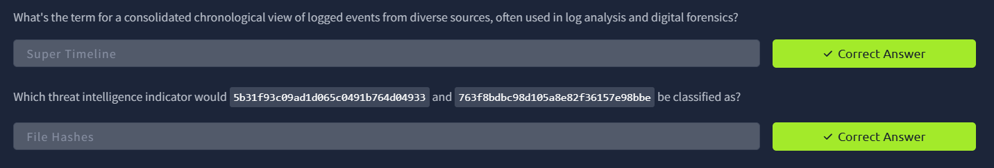

TASK 4 – Detection Engineering

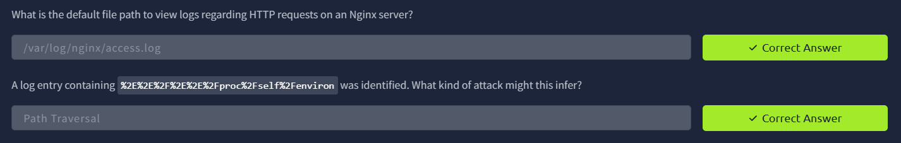

TASK 5 – Automated vs. Manual Analysis

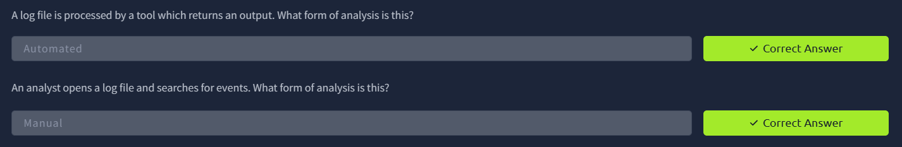
TASK 6 – Log Analysis tools: Command Linux

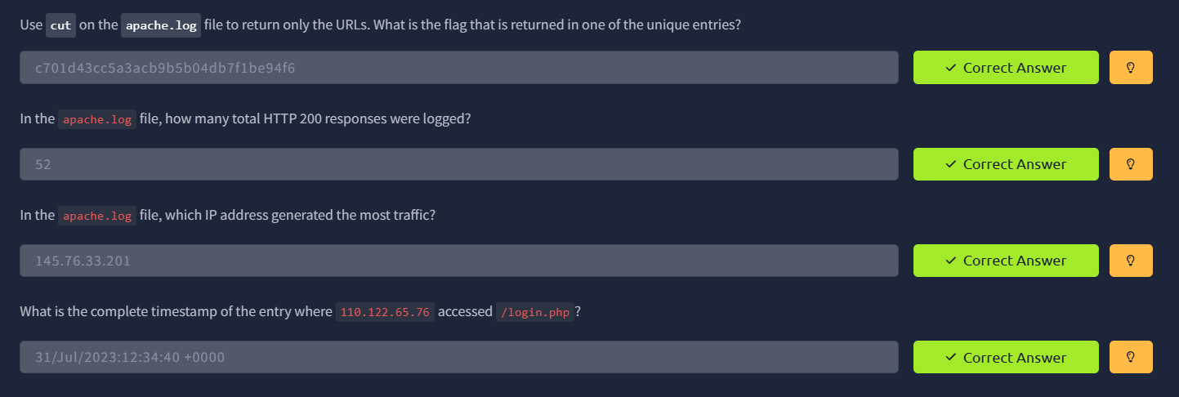

TASK 7 – Log Analysis Tools: Regular Expression

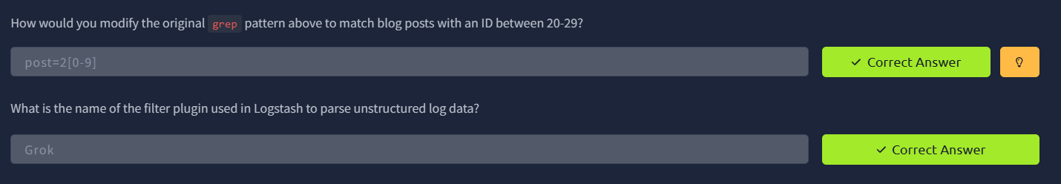

TASK 8 – Log Analysis Tools: Cyberchef

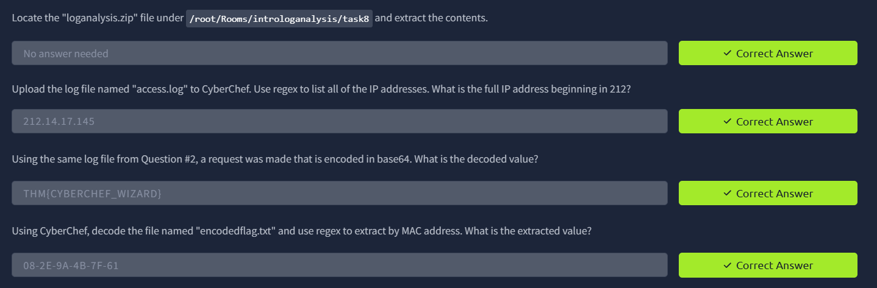

TASK 9 – Log Analysis Tools: Yara and Sigma

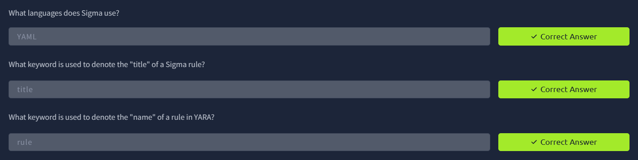

RESULT

Successfully learned the importance of log analysis, best practices, and tools used for detecting, investigating, and responding to security incidents.

